Troop 122
Parent’s Guide

Evans, Georgia

Boy Scouts of America
Georgia/Carolina Council
Kiokee River District

Chartered by:
Lewis Memorial United Methodist Church

- Organization:

The Boy Scouts of America is a national movement, and so, by its nature, is a complicated organization. The national organization is divided into Regions and within each region, into Local Councils. Councils are further divided into Districts. Troop 122 is in the Kiokee-River District of the Georgia-Carolina Council. The Council advises, offers training courses, sponsors council activities, and is the go-between for individual units and the Regional and National Offices.

To operate officially as part of the program, the Troop must possess a charter granted by the Boy Scouts of America. To qualify for a charter, the Troop must have the sponsorship of an approved organization. Lewis Memorial United Methodist Church, located at 5555 Hereford Farm Road, Evans GA is our chartered organization. The church provides us with a meeting place, financial support, gives assistance when called upon, and provides tremendous leadership.
The troop is made up of two primary groups, Committee and Program:

Committee:

- The committee is headed up by the Committee Chairperson. That person is responsible to the Sponsoring Organization and District/Council for all matters involving the troop. The chairperson is supported by a host of committee members in various positions. The committee provides administrative support for the troop operation and ensures the program is in accordance with BSA policy. There is a committee meeting held monthly to discuss the business of the troop. All parents are invited to attend. See the troop calendar for meeting dates.

Program:

Adult Leadership:
- The scout program is headed up by the Scoutmaster (SM) who is responsible to the Committee Chairperson. With the help of Assistant Scoutmasters (ASM), the Scoutmaster ensures that each scout meets the requirements laid out by the BSA Guide to Advancement and troop activities are conducted in a safe manner per the BSA Guide to Safe Scouting. The goal is for the scouts to have fun and learn by doing scouting and leadership skills, all the while in helping them grow into useful citizens and fine young men.

Scout Leadership:
- This troop is a scout lead troop. The scouts have control of planning the meetings and activities of the troop with guidance from the adult leadership. The troop is broken up into smaller groups known as patrols; each patrol is led by an elected Patrol Leader (PL) and Assistant Patrol Leader (APL). The patrols as a group are led by the elected Senior Patrol Leader (SPL) and Assistant Senior Patrol Leader (ASPL). There are several assigned positions for the scouts that include: quartermaster, scribe, troop guide, historian, librarian, chaplain’s aide, instructor, den chief, JASM, etc. The scouts conduct a Patrol Leader Council (PLC) Meeting monthly to plan meetings and activities. The troop calendar will show meeting dates. PLC usually coincides with the Committee Meeting.

See Attachment ‘A’ for Sample Troop Organization Flow Chart.

Parents are encouraged to become adult leaders in the troop with either the committee or program side of the troop. There is always a place for you to get involved. To get started, fill out an adult application and take Youth Protection Training on-line at myscouting.org.

For all activities, we are required to have at least 2 adults present. In addition, at least one adult must be trained and certified in Youth Protection, First Aid, and CPR. Generally, once we register adults who want to participate in troop activities, we encourage them to receive the required training for their position.

Registration covers the adult leader with supplemental accident insurance and provides reassurance to the Troop by the required Council background check. Registered adults receive Scouting magazine, another resource for news in the scouting movement and ideas for programs that can be brought to our troop.

- Membership Requirements:
Eligible to join the troop are boys who have completed the 5th grade and are 11 years old, and/or have earned the Webelos Arrow of Light Award and 10-1/2 years old, but are younger than 18 years of age.

Upon deciding to join, the boy and his parents are given Youth/Adult Applications, Health & Medical Form, Parent’s Guide to Troop 122, Troop Resource Survey, Merit Badge Counselor Application, Troop Activity Schedule, and Adult Leader Listing.

After applications are signed and fees collected the boy is then accepted as a member of Troop 122.

Standards of Membership:
- The troop expects each of our scouts to be active, to advance regularly, and to wear full scout uniform when required, practice good manners and behavior, and to do their best to live by the Ideals of Scouting (Oath, Law, Motto, Slogan, Outdoor Code, & Leave No Trace)

- Scouts are expected to attend a majority of weekly meetings, weekend campouts, summer camp, and service opportunities planned by the troop. The troop understands that scouts have activities and family events outside of scouting and that some troop meetings/activities will not be attended. Scouts should notify their Patrol Leader or Senior Patrol Leader if they will be absent.

- Troop Meetings:
- Weekly troop meetings are held on Tuesday nights at LMUMC, Hereford Farm Rd. /Columbia Rd., Evans GA.

- Meetings start at 7:00 PM and close approximately at 8:30 PM. Meeting schedule follows the school calendar, so if schools are closed, there is no scout meeting, unless otherwise planned in advance.

- Scouts are expected to wear their class ‘A’ uniform to troop meetings. Scouts are allowed to wear class ‘B’uniforms during the summer months when approved by the Scoutmaster.

- Scouts will need to bring their Boy Scout Handbook to each meeting/campouts to allow sign-offs of completed requirements.

- Checkout with the Scoutmaster or Assistant prior to leaving meetings/activities for home.

- Boy Scout Uniform:
- The official Boy Scout Class-A uniform includes the khaki tan shirt (See attachment “B” for patch locations), olive green pants. When wearing olive green scout shorts, Boy Scout socks are required. Boys are expected to be in full uniform at all troop meetings, board of reviews, courts of honor, and designated activities.

- The only insignia that carries over to the Boy Scout tan uniform shirt from Cub Scouts is the Arrow of Light Award and World Crest patch.

- Class ‘B’ uniform consists of Troop T-shirt and scout pants/shorts. Troop T-shirts can be purchased through our troop office. New Class ‘B’ Shirts are ordered each year prior to Summer Camp.

- The Georgia-Carolina Council Scout Shop has all of your uniform and camping needs. As well as, scouting literature for all you’re scouting roles. The following is the address and contact info for the Scout Shop:

Store Manager: Mo Lessard, maureen.lessard@scouting.org
Store Phone Number: 706-821-8777
Address: 4132 Madeline Drive, Augusta GA
(Off Jimmy Dyess Pkwy between 1-20 and Gordon Hwy)
Store Hours: Monday thru Friday, 10:00am – 6:00pm
Saturday, 10:00am – 4:00pm, Sunday, Closed

- Advancement:
Boy Scout advancement requires much individual effort and initiative. It also emphasizes leadership and service as much as badges and skills. To advance, a scout must be active, do his best to live by the Ideals of Scouting, practice leadership, give service to others, and learn scout skills and earn merit badges from qualified merit badge counselors.

Parents can help their scout by providing encouragement to be active in the troop meetings, activities, campouts, and summer camps. Know what your scout needs for his next rank by reviewing advancement requirements listed in the Scout Handbook. Parent’s interest in scouting has been demonstrated to be essential ingredients to a scout’s advancement, participation, and enthusiasm in scouting. But, to a degree the parents need to let the scout communicate advancement needs to his Patrol Leader, Senior Patrol Leader, and Scoutmaster on their own. This gives the scout ownership and responsibility for their progress toward the rank of Eagle.

An adult leader who is known as a ‘Life to Eagle Advisor” is available to aid Life Scouts with their Eagle project and application paperwork. Sometimes the scout and parents can get overwhelmed with the paperwork process.

Although the rate of advancement varies considerably among individual scouts, the majority progress at the following rate:
- After 1 year in the Troop: 1st Class or 2nd Class
- 2 years in the Troop: 1st Class or Star
- After 3 years in the Troop: Star or Life
- After 4 years in the Troop: Life or Eagle (the latter is the exception)

After completing all the requirements for a rank, a scout meets with the Scoutmaster or assistant in a “Scoutmaster’s Conference” to discuss their moving to the next rank and what is expected of them. Once completed, the scout schedules a Board of Review with the Advancement Coordinator. The Board of Review is a final, unbiased review of Scouts accomplishments by Troop Committee members.

Merit Badges

There are many opportunities to earn merit badges throughout the year. Such as, Troop Activities, Merit Badge University, School Activities, and Summer and Winter Camps. Many merit badges are available to choose from by your scout. There are some that are required to be completed for Eagle Scout with a few additional elective merit badges that the scout can choose. Reference the Boy Scout Handbook for requirements for each rank where merit badges are required.

Merit Badge Completion Flow Chart:
- Scout determines merit badge he is interested in taking, and then talks to Scoutmaster.
- Scoutmaster assigns a merit badge counselor to the scout by issuing a blue card with counselor’s information.
- Scout schedules time with counselor to take classes.
- As requirements are completed by the scout the counselor signs-off on the blue card.
- Once requirements and sign-offs are complete, return blue card to Scoutmaster.
- Scoutmaster reviews blue card and signs off on card for completion.
- Scout takes completed blue card to Advancement Coordinator for processing.
- Merit Badges will be presented to scout at the next Court of Honor.

- Merit Badge Counselors need to be a registered adult who has knowledge in the field to be taught, and have taken Youth Protection Training. The scoutmaster approves the counselor prior to the scout starting the merit badge to verify that the counselor is registered and have taken Youth Protection Training.

- Summer/Winter Camps and Merit Badge University or Clinics have confirmed the training and registration of counselors up front in most cases.

- In cases where the person that is needed to teach a merit badge is not registered or trained in Youth Protection. The scout can take an Adult Application, Merit Badge Counselor Form, and instructions for them to take Youth Protection Training at my scouting.org. No charge for registering as a counselor.

- Where possible, for youth protection and benefit to the troop, scouts are to take merit badges in groups rather than as individuals. Individuals will need to have parents or another youth protection trained adult in attendance to adhere to BSA Youth Protection Policy.

- It is recommended that scouts keep up with their rank advancement and merit badge cards in a three ring binder with inserts similar to what baseball cards are kept in. These cards will come in handy during the Eagle Scout Application process.

- Overnight Camping Trips:

Weekend Campouts
- The troop will plan an overnight camping trip most months during the year. Camping trips usually consist of leaving on Friday evening from LMUMC and returning Sunday afternoon around 1:00pm.

- The scouts camp in patrols; they set up camp, cook their own food, wash dishes, as well as plan the activities. Food menus are planned by the scouts. Grubmasters are assigned to shop and keep the food for their patrol until the campout. Coolers can be provided by the troop.

- Overnight camping trips allow the scouts to hone their scout skills and to work on rank advancement and merit badge requirements.

- Scouts must have a signed permission slip and for each overnight camping trip and other troop activities. Scouts will need to complete, one time only, a Medical Health Form, Parts A & B for short duration camping trips.

- The cost of the overnight activities is determined by camp site, transportation, food, and equipment rental cost. All camping fees must be paid in advance of the activity. The troop encourages you to provide payment to the treasurer who will deposit payment into the scout’s personal scout account to handle these fees. Approximate cost for campout is $25 - $30.

- Swim test are conducted by the troop on an annual basis or as needed during the year to determine the scout/adult swimming abilities. Activities and requirements allowed for designated swimmer, beginner, or non-swimmer are specified in the Guide to Safe Scouting at scouting.org.

Summer Camp
The troop will plan at least one week long summer camp for your scout to attend. Where the scouts have an opportunity to complete Merit Badges that may not be readily available at other times of the year, as well as, Eagle required and ones they may just have an interest in attending.

- First year scouts can get a head start on their Tenderfoot thru First Class ranks by attending programs geared to teach scout skills for those requirements.

- Scouts will sleep in either side wall tents or dome tents and on cots, dine in a dining hall for three meals a day, and have an opportunity to participate in a wide variety of activities outside of their classes.

- Summer camp requires the scout to have a completed BSA medical form, Parts A, B, & C, with a signature from medical personnel. This medical form is valid for 12 months. Different camps have similar amenities on a smaller or larger scale.

- Estimated cost of summer camp is from $250.00 to $350.00 dollars. The scouts have opportunities during the year to raise funds through fundraisers to add money to their scout accounts for camp. Summer camp fees are required paid in full prior to camp. Payments can be paid by installments to the Troop Treasurer for deposit into the scout’s personal scout account during the year.

- Class ‘A’ uniform is required for traveling to and from camp, meals, and campfire activities during the week. Class ‘B’ uniforms are worn during the day at class and in the evening after supper.

- Equipment:

The troop provides most of the equipment the scouts will need on a regular campout, such as, tents and cooking equipment. The troop has a troop trailer that carries all the equipment on the campout. Each patrol is assigned a patrol box that consists of stove, griddle, cooking utensils, and other supplies.

- For weekend campouts; personal gear can be carried in duffle bags, backpacks, or book bags. Long duration type camps, such as summer camp, the scout can use a foot locker or large duffle bag. Foot lockers seem to work the best.

- The Scout Handbook has a suggested list for you to follow in selecting gear your scout will need to take on a campout. Also, see Attachment ‘D’, ‘Personal Equipment Checklist’ prepared by the troop.

- Label all personal gear with the scout’s name.

- Discipline:

Recognizing that boy behavior problems will inevitably occur, the Boy Scouts of America have addressed management of boy behavior problems in their training programs, the Scoutmaster's Handbook, and BSA Guide to Safe Scouting. The Scoutmaster is responsible for the control of boy behavior, health and safety, and discipline of the Troop.

Such behavior as stealing, smoking, use of alcohol or illicit drugs, lying, swearing, cheating, fighting or other physical aggression, possession or use of fire crackers, incendiary devices, explosives or knives other than folding pocket knives, hazing, harassment and violation of health and safety rules, etc., will not be tolerated.
- Character growth and citizenship training are among the purposes of the BSA, counseling by the Scoutmaster and peer pressure by the boy leadership in the spirit of the Scout Law are the methods used in administering discipline.

- In order to recognize behavior problems and to control them it is essential for the Scoutmaster to have an adequate number of adult assistants to work under his direction at every event.

- In most cases, boys respond well to counseling by the Scoutmaster with no further action being required. Obviously, imminent threats to health and safety must be dealt with firmly. In more persistent or egregious misbehavior cases the Scoutmaster will confer with the boy's parents. In a few cases the parents may become aware of behavior problems before the Scoutmaster, in which case, they should communicate directly with the Scoutmaster as soon as possible.

- If after a parent-Scoutmaster conference, a behavior problem persists or is sufficiently flagrant the parents will be asked by the Scoutmaster to permanently remove the boy from the Troop.

- In the case of difference of opinion between the parents and the Scoutmaster, the matter will be referred to the Troop Committee Chairperson who may resolve the problem or refer it to a full and fair hearing composed of at least five registered Troop Committee members.

- Rarely, adults and parents who accompany the troop can be the source of behavior inconsistent with the principles of Scouting. In such cases, all persons attending a troop function must recognize the leadership and responsibility of the Scoutmaster or, in his absence, the designated registered adult leader.

- Proper performance of the Scoutmaster is the responsibility of the Troop Committee Chairperson assisted by the Troop Committee as required. Parents can contact the Committee Chairman with behavior by the Scoutmaster or Assistant Scoutmasters not in accordance with the principles of scouting and the BSA Guide to Safe Scouting.

- Finance
Troop operating expenses are based on the activities planned by the scouts and approved by the scoutmaster. The PLC and the Scout Leaders meet and plan annual activities.
- A scout’s account is set up to collect money earn by your scout at fundraisers and by funds the parent deposit into the account. The money goes towards paying for monthly camping fees, summer camp, troop dues, etc.

- Troop dues of $7 are drawn from the account each month, which goes towards awards, badges, patches, advancements, and office supplies for the troop.

- Fundraisers are organized though out the year to assist the scouts with raising money for camping fees and activities. A small percentage of money earned goes into the troop account for purchase/maintaining of equipment.

- The account is maintained by the Troop Treasurer. Payments to the scouts account should be made out to Troop 122 and given to the Troop Treasurer to be deposited.

- Account statements will be sent out to the parents to reflect the activity on the account with deposits and withdrawals. It is the responsibility of the parents to maintain a positive balance in their scouts account to pay for upcoming troop activities and re-charter fees.

- Program costs should not be a limiting factor that prevents a scout from attending a function. Please contact the Committee Chairman or Scoutmaster to discuss alternative payment methods prior to the event.

- Parent Participation:

Scouting is a family affair. All adults affiliated with the Troop are non-professional Scouters and all are volunteers. BSA offers formal training for any interested volunteers. All have the same objective, to provide boys in the community with the opportunity to have fun and learn scout skills while helping them grow into useful citizens and fine young men. No Scout is expected to travel the Trail to Eagle by himself. To accomplish these scouting goals it takes many adult volunteers. Your participation is required if your son's Troop is to be successful. Parents should encourage their son to work on advancement and take full advantage of the Scouting program. Parents are invited to all Troop meetings and especially to Courts of Honor, which are held quarterly.

It is very important that the parent not let their own Scout Experience (how we did it back then) interferes with the one that their son will have on his own. Each Scout needs to experience Scouting on their own. The volunteering parent needs to treat all scouts equality. In other words, when volunteering you do not have a son in the troop.

Also, parents normally may not sign off on advancement or merit badge requirements for their own scout. Advancement requirements may be taught by other scouts in the troop and verified by a First Class Scout or higher but, only the Scoutmaster or assistants may sign off advancement requirements. Merit badges must be signed off by the registered merit badge counselor. For parent counselors, it is best to have multiple scouts earning the Merit Badge rather than one on one with their scout, if at all possible. The Scoutmaster would still need to sign-off on blue cards and the merit badge counselor prior to taking class.

Given below is a partial list of jobs that require scout parent volunteers. Please look this list over and discuss your choice with the Committee Chairperson or the Scoutmaster. You are definitely needed to assist in providing the best Scouting program possible.
- HELP AT TROOP MEETINGS: If you have previous experience in Scouting or enjoy working with boys of Scout age, volunteer to help at Troop meetings. Contact the Scoutmaster. We are always looking for new Assistant Scoutmasters.

- TRANSPORTATION: Cars and drivers are needed to transport Scouts and equipment to monthly camp outs or other scouting events.

- MERIT BADGE COUNSELOR: Men and women are needed to instruct and certify Scouts who are interested in pursuing the merit badge for which you could be the counselor. BSA offers over 120 merit badges covering almost all vocations, professions, and hobbies. Contact the Advancement Chairperson on how to sign up.

- OUTDOOR PROGRAM: If you enjoy the outdoors and can spare an occasional weekend for camping, you are urgently needed to help with the outdoor program and to share your skills with the Scouts. Please contact the Outdoor Programs Coordinator on the Troop Committee.

- BOARD OF REVIEW MEMBERS: Adult committee members are needed to serve as members of a board which reviews the Scouts who are ready for advancement in rank. This group convenes on an as-needed basis, normally several weeks before a scheduled court of honor. Contact the Advancement Chairperson on the Troop Committee.

- TROOP COMMITTEE: Parents are needed to assist in setting Troop policy and guidelines and providing the resources that allow the Troop to function. The meetings are usually held in the troop office or conference room at the church. All parents are welcome at every meeting whether a Committee Member or not. Contact the Committee Chairperson with questions.

- FUND RAISING: While there are various means of meeting expenses, it has been found most efficient and expeditious to raise the necessary funds through money raising projects. Your help is needed, from time to time, to provide transportation and assistance to the scouts as they work together to support their troop and raise money for their scout accounts. A percentage of funds collected go to the troop treasury, but the majority is divided into the scout accounts of those who participated in the fundraiser. All in all, you can see that there are many ways that you can serve the Troop. Your help is very much appreciated.

- Attachments:
  - Sample Troop Organization Flow Chart
  - Uniform Patch Placement
  - Troop Resource Survey
  - Personal Equipment Checklist
  - Troop Contact List

ATTACHMENT “A”
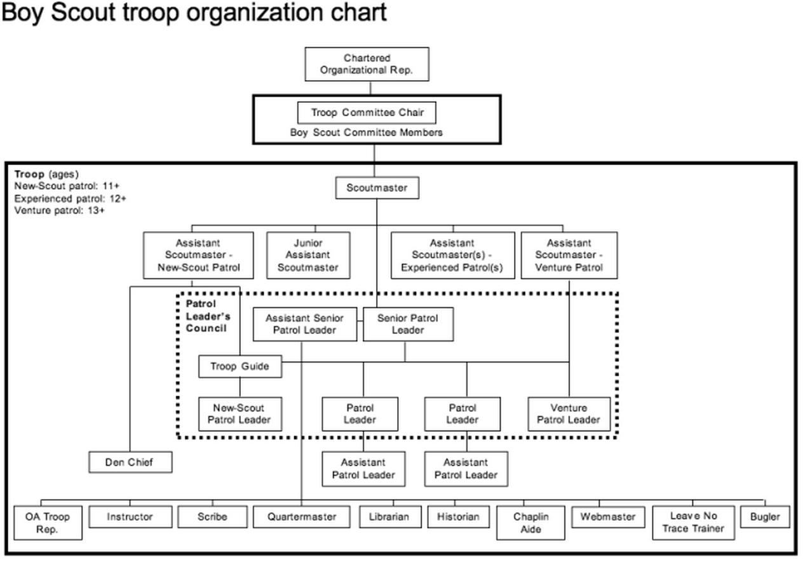

ATTACHMENT “B”

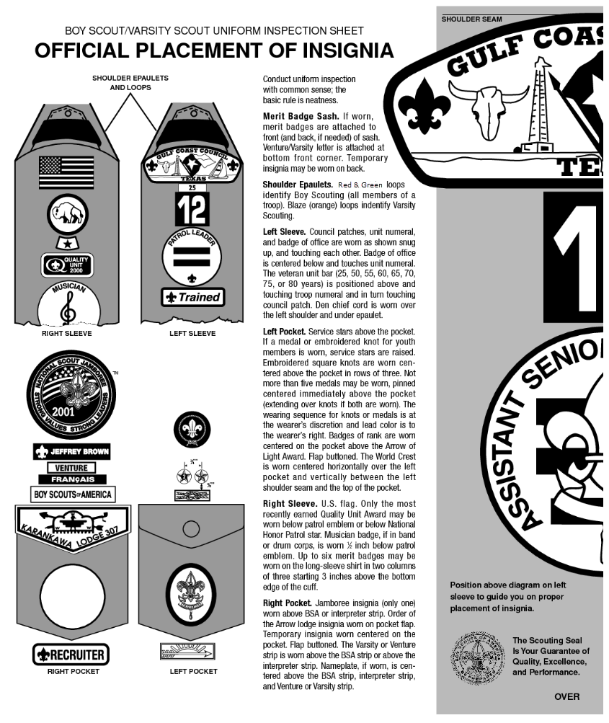

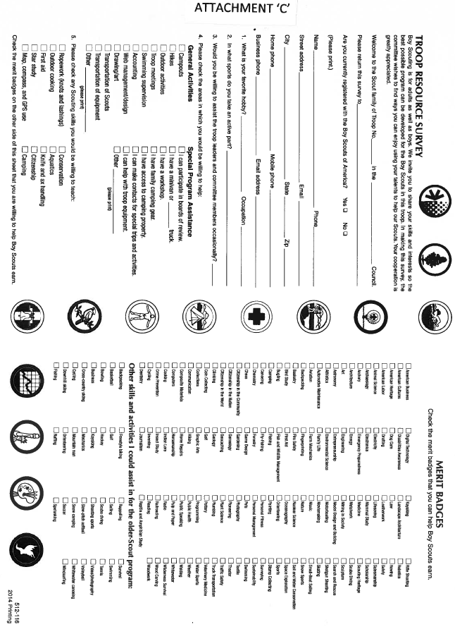

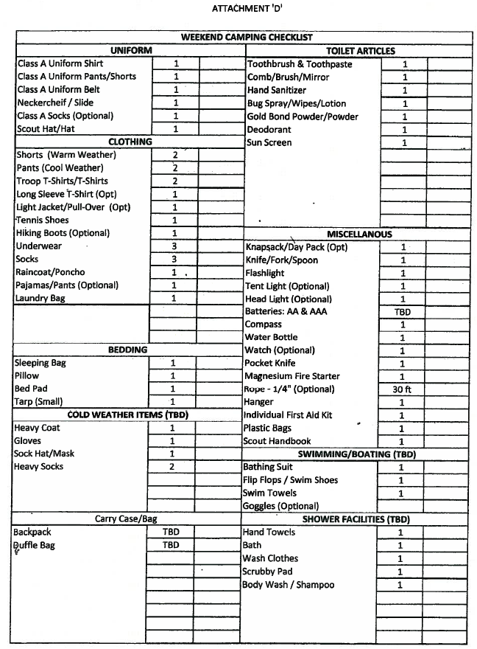

ATTACHMENT “E”

TROOP 122

CONTACT LIST

Scoutmaster Darryl Furby furbster@hotmail.com

Committee Chair Jeff Gagnon gagnonjm2004@yahoo.com

Charter Org Rep Mark Dickson mvdickson@sbcglobal.net

Secretary Rebecca Martin doherra@gmail.com

Treasurer Karen Cummings karenlynne80@gmail.com

Advancement Benjamin Reynolds benjaminreynolds1979@gmail.com

Popcorn Kernal

Service Hours ShawnaLee Rivas shawnalee.rivas@yahoo.com

Membership Chair

Fundraising

Training

ASSISTANT SCOUTMASTERS

Leland Kerstetter usleemc@yahoo.com

Keith Drudy kjdrudy@yahoo.com

Jacob Darlak

Logan Klepal

NOTES:

